Introduction to informatics

Homework 3: Functions

### Exercise 1:

Write a program that:

1. defines and implements the function calculateAverage, which takes two notes.
2. in the function main, asks the user for two notes, then calls this function calculateAverage and finally displays the result returned by this function calculateAverage.

Answers

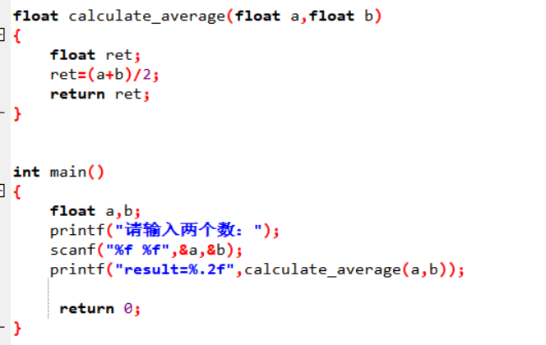

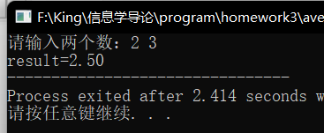

### Exercise 2:

Write a program that:

1. defines and implements the function calculateArea, which takes a side length of a square and returns the calculated area
2. defines and implements the function calculatePerimeter, which takes an argument for a side length of a square and returns the calculated perimeter
3. in the function main, call these two functions for a square of side length 3. Display the results on the screen

Answers

### 

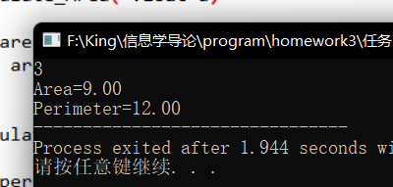

### Exercise 3:

Write a program using an F function to display the table of values of the function defined by

$$f\left(x\right)=\sin\left(x\right)+\ln\left(x\right)−\sqrt{x}$$

where x is an integer between 1 and 10.

Answers

